#### 

Athlone Institute of Technology

Athlone

REPORT

IRELAND WEATHER

CLIENT-SIDE TECHNOLOGIES

A00258745

Meet Mehta

**ABSTRACT**

A website which provides the weather conditions and forecasts of any city located in Ireland.

The main 3 phases of website:

1. **Loading the list of cities**: List of city in json format is taken from openweathermap. This cities will be loaded to select box so that user can choose from it.
2. **Making AJAX request**: The AJAX request will be sent to openweathermap along with city chosen by user. The response comes in XML format which is parsed and presented in meaning manner.
3. **Displaying forecasts data**: Characteristics of weather will be displayed in card layout for better user experience
4. **Making graph for Visualization**: Data parsed from XML will be used to make graphs. It makes it easy for users to perceive information.

This project is made using HTML5, CSS3, Bootstrap and JavaScript. Additional libraries like bootstrap, leaflet and charts are also used.

**INTRODUCTION**

OpenWeatherMap is a weather forecast website which provides API’s to get weather data.

Ireland Weather uses these API’s to give us the weather forecasts for any city located in Ireland. In weather forecasts, it provides some details about the weather such as:

* Temperature – (current temperature, minimum and maximum temperature)
* Pressure (in hPa)
* Wind Speed (in mps)
* Humidity
* Condition of climate (scattered clouds, light rain, few clouds etc)

It is a website which would be helpful for any user who wants to check the weather condition or wish to know about the climate variations.

Some features of website include:

* Choose from the wide range of cities or Enter the city’s name.
* Current weather status showing location of city on world map.
* Weather forecasts for next 36 hours (in a group of three hours).
* Other information about weather displayed on interactive card layout.
* Image showing the current time and whether it is day or night.
* Data Visualization using charts.
* Line Graph to show variation in Temperature, wind speed, pressure & humidity.
* Bar Graph to show different precipitation over time.
* Pie Chart to show the distribution of climatic conditions over time.

**SCOPE OF WORK**

**Objective:**

The main objective of the project:

* To provide the predictions of weather for the city entered by user.
* To display information in a meaningful and attractive manner.

**Limitations:**

* List of cities:
* Only finite number of cities from Ireland are supported.
* It can be extended to get all cities from openweathermap’s json file.

**Environment:**

Hardware :

Processor : Intel Core i3

Random Access Memory : (Minimum) 512 MB

Hard Disk : 1 GB

Software :

Front-End : HTML, CSS, Bootstrap

Scripting : JavaScript

Operating System : Windows10

Server : XAMPP

**Libraries Used:**

* Charts.js – For using charts.
* Leaflet – For using maps.

**Technologies Used:**

* HTML
* CSS
* Bootstrap
* JavaScript
* AJAX
* XML

**IMPLEMENTATION & FUNCTIONALITIES**

* **Getting City List:**
* Openweathermap recommends us not to get weather data by using city name to avoid ambiguity. So, we are using city ID to get data.
* 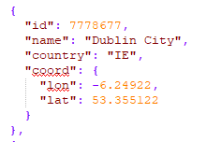Openweathermap provides list of cities along with their ID’s and country in a json file named as city_list.json. It contains details in following way :

* This list is used to populate the select box in HTML through JavaScript. The city name will be option text and city ID will be option value.

Such that : <option value="7778677">Dublin </option>

**Implementation :**

* Create Select element in HTML with id - ‘city-dropdown’ and then assign it to variable ‘dropdown’ in JavaScript. Then clear the select box by making its length 0. Also, add the default option with value as ID of Athlone City.

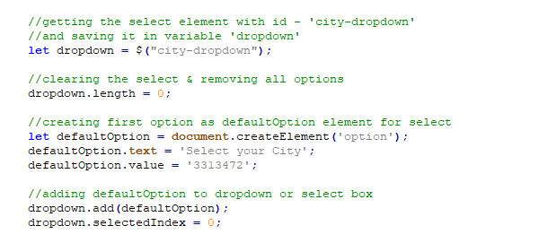

* Make AJAX request to the JSON file which contains the list of cities. Get the count of cities and create that much option elements. Text of option will be the city Name & Value will be city ID Add each of these elements to select box.

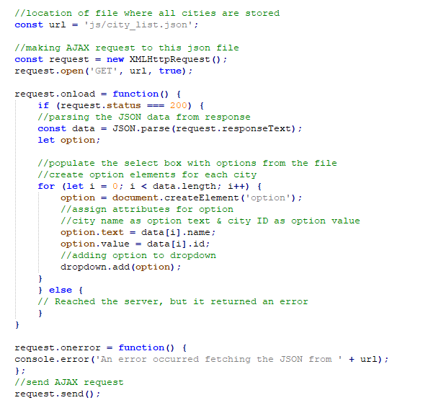

* Populating city list from city_list.json

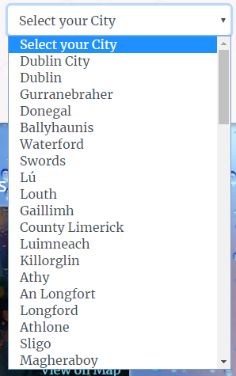

* **Matching Textbox with Select:**
* Assigning textbox with select box. So, user can have both the options either enter the city or selecting the city.

**Implementation:**

* Match Textbox entry with options from select box. If entry matches, that option get selected otherwise default option will get selected.

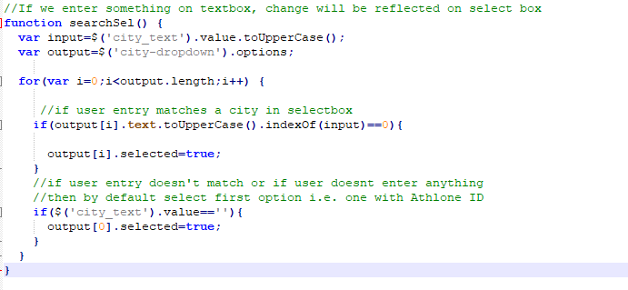

* Getting user input and selecting option as per input

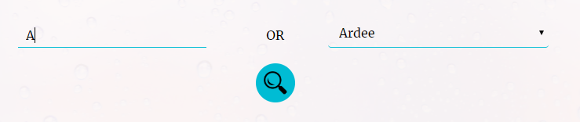

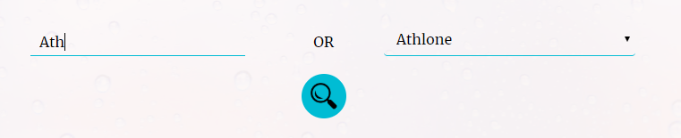

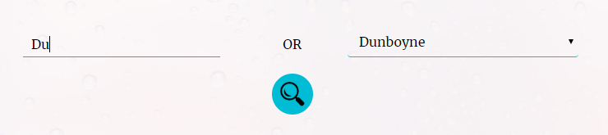

* **Getting weather data & Creating elements accordingly**
* Using City ID to get the weather forecasts for next 36 hours.

**Implementation:**

* Assignbtn**_**click function to search button.
* Get the value of selected option.
* Perform AJAX request to openweathermapAPI. Send the appid and city ID in the url.
* On success response call get_weather() function.

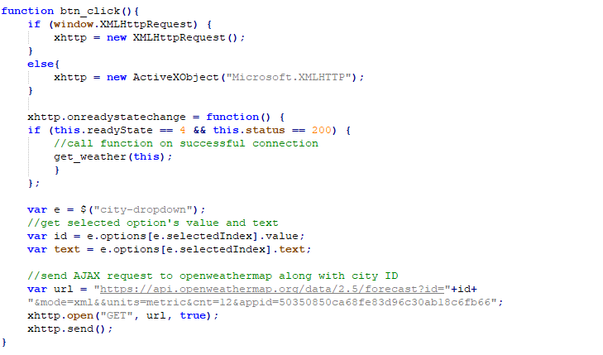

* Extracting the XML data which we got from AJAX request.
* Creating document elements and populating it with weather data.
* Getting all the forecasts with time tag and extract all the weather details.
* Creating the weather card based on climate. Different climate will lead to different card. For eg. Rainy card for Rain, Sunny card for Summer etc.
* Getting the image from openweathermap based on climate.
* Creating carousel for all the cards for better user experience.

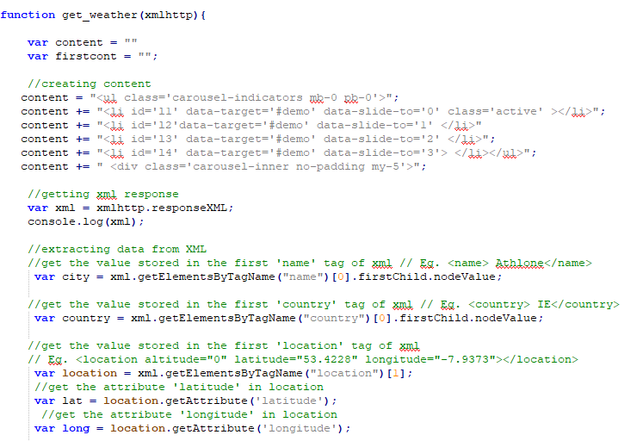

* Extracting all time forecasts and creating weather-card accordingly

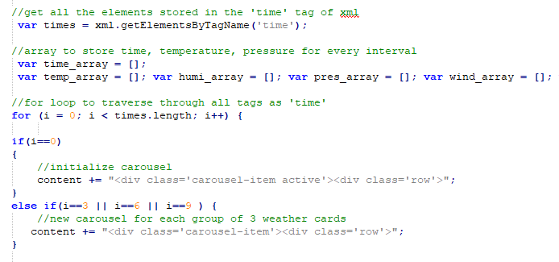

* 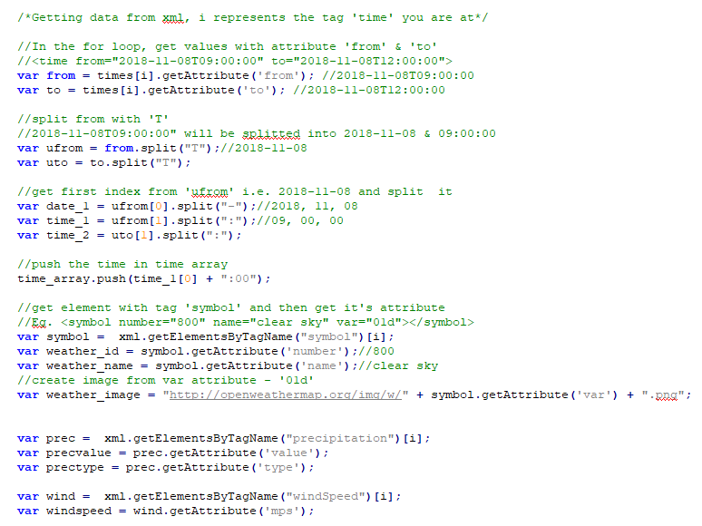Extracting attributes from every forecast (every tag name ‘times’)
* Creating Weather card for different weather codes

For eg. If weather code is 800, it means clear sky. So, sunny card will be created.

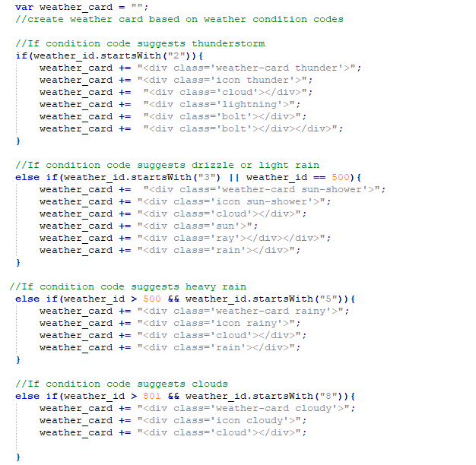

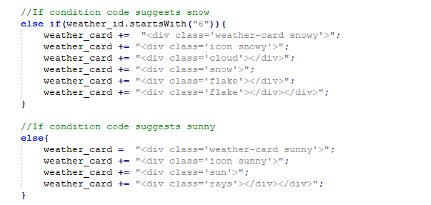

* 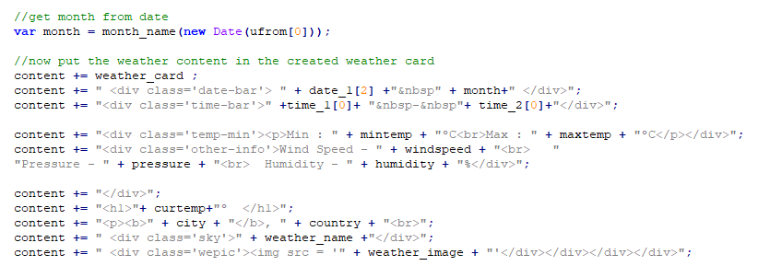Filling weather card with weather data
* 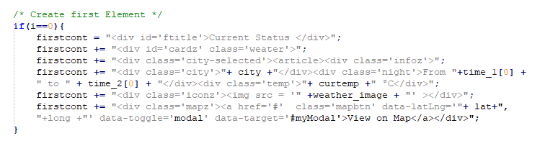Creating a special card for current time (i.e. first 3 hour)
* 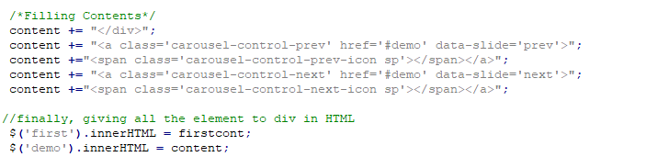Closing carousel & using innerHTML to create all the elements
* 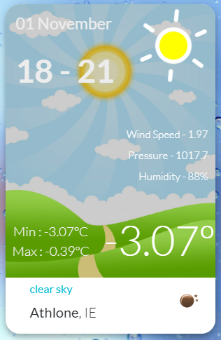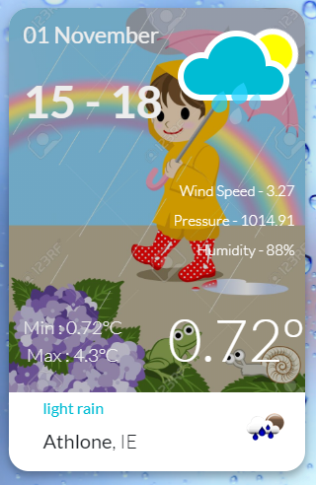Creating different weather card for different weather conditions

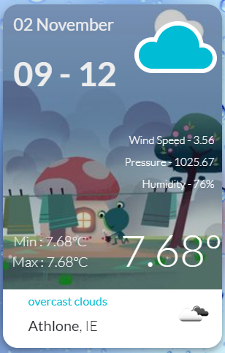

* Creating special weather card for current time

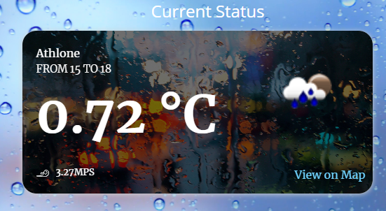

* Carousel for weather cards

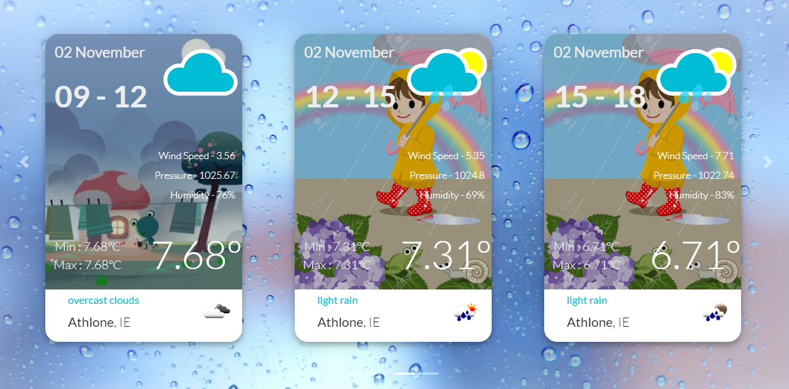

* **Creating graph for Visualisation**
* Line graph to display variations in temperature, windspeed, humidity & pressure.
* Bar graph to display different precipitation over time.
* Pie chart to display distribution of weather conditions.

**Implementation:**

* Make chart div visible & add title for chart.
* 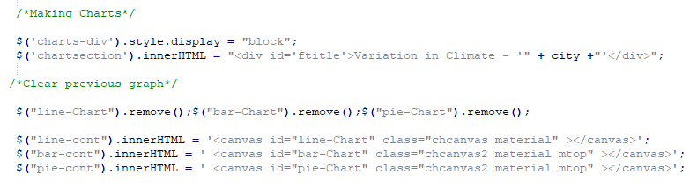Clear previous canvas charts and add new canvas for new charts.
* Create ctx variable using context from graph div.
* Create chart on that ctx using Charts.js library.
* Set the array with weather data as labels and data.

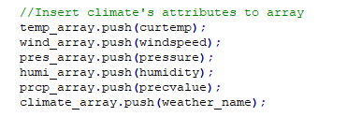

* 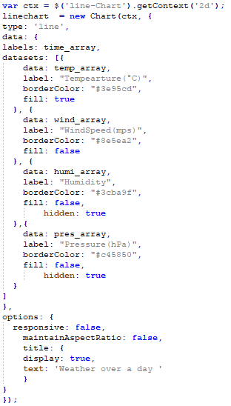Line Graph.

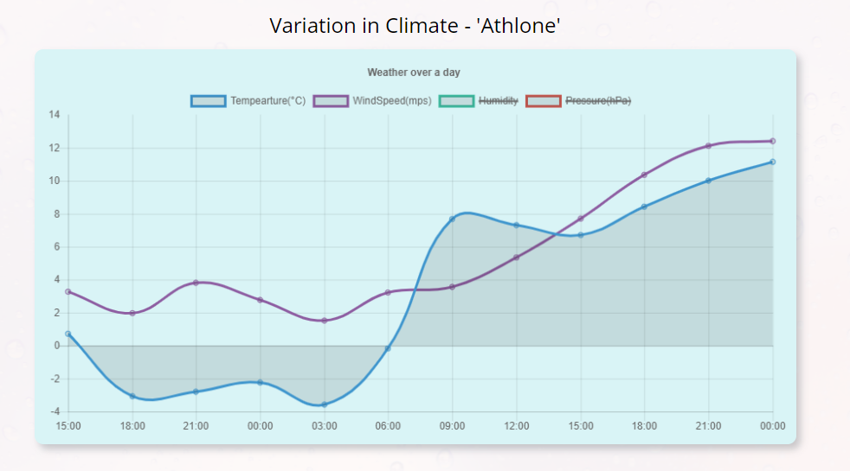

* Bar Graph

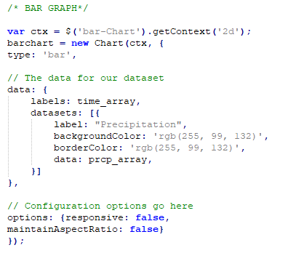

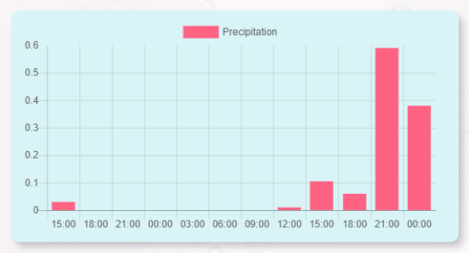

* Pie Chart
* Store different climatic conditions in array. Then, create two more arrays, one with unique weather condition and another one with no. of occurrences of that condition.

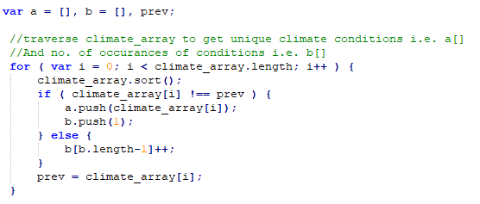

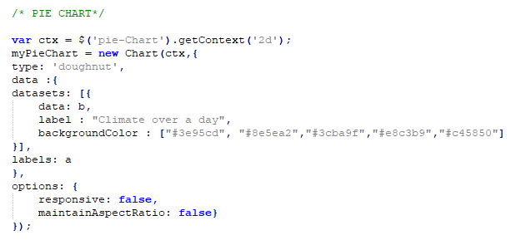

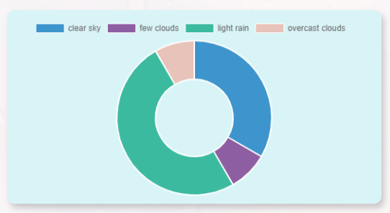

* **Showing City location on Map**
* The city selected by user will be displayed on world map.
* Map will be displayed on bootstrap modal.

**Implementation**

* Create Modal and pass latitude and longitude of the city. Lat & Long is taken from XML data.

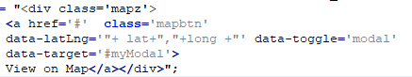

* Add script to get this latitude and longitude and display it on the map using leaflet map API

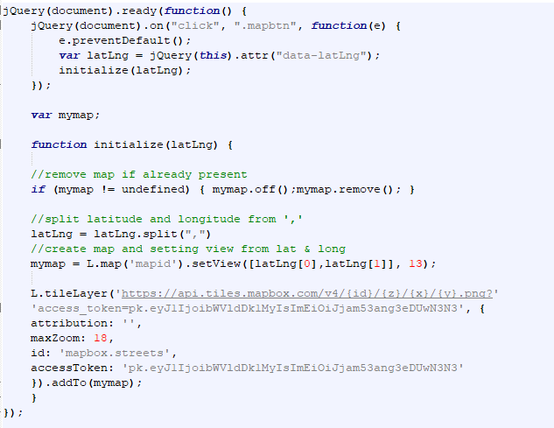

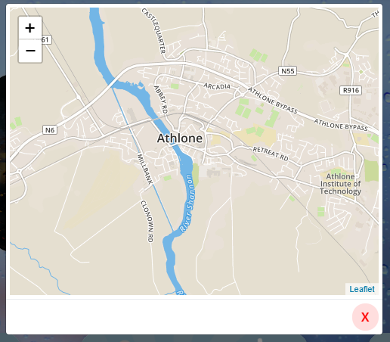

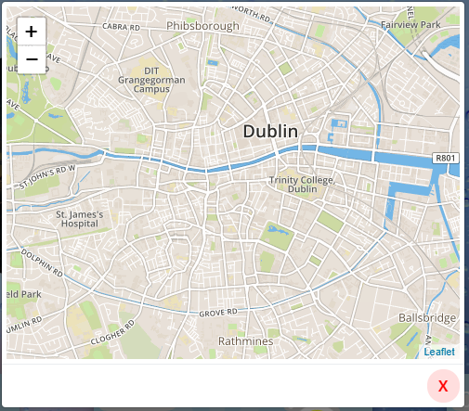

**SCREENSHOTS**

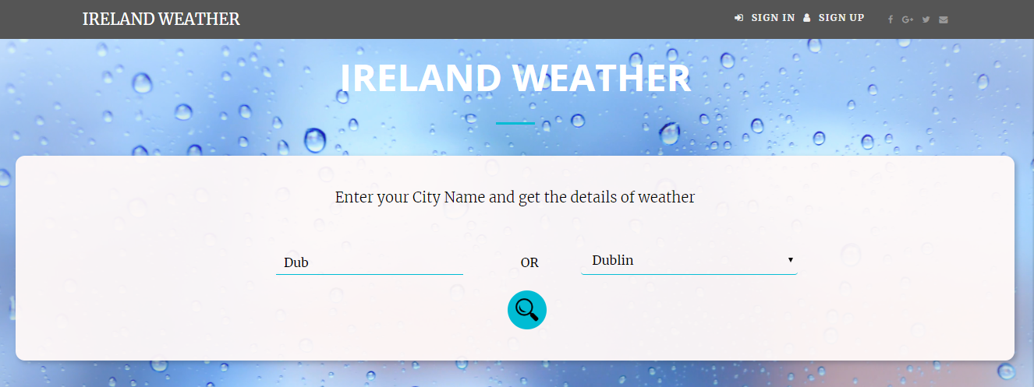

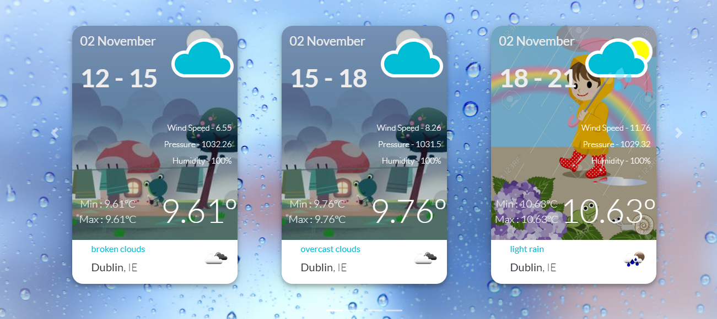

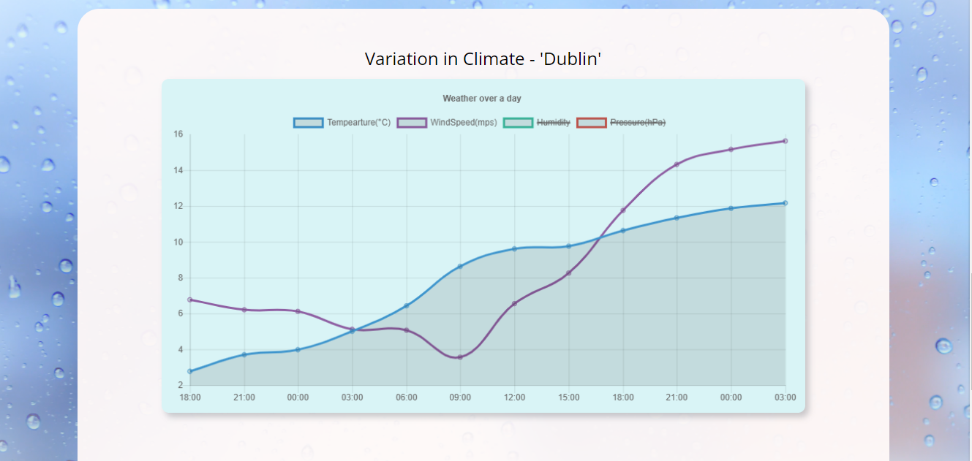

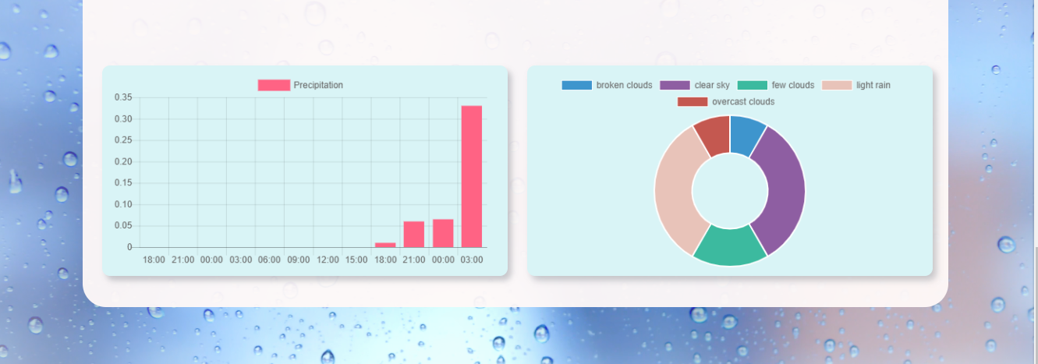

**CONCLUSION & LEARNINGS**

Getting the weather forecasts can make one’s life easier for sure and Ireland Weather is one step towards it. Ireland Weather successfully provided the data in a set of hours for next 36 hours.

All the data from XML was parsed and presented in card layout successfully.

- Openweathermap provides API that can be easily consumed and all the data about weather forecasts can be used with appid. The data can be fetched either by using city ID or city name & country name.

- Charts.js provides various charts that are easy to implement and provide good user experience.

- Leaflet is one of the best alternative for Google Maps API since Google Map API is paid.

**FUTURE SCOPE**

Current Scope of this project is limited to the cities of Ireland. We can extend it to add all the cities from list to select box.

Also, data can only be extracted as a set of 3 hours. We can provide functionality to provide data for every day or for every specific hour. We can also extend the system to provide specific time so that only weather for that time will be shown.

There are three graphs for data visualisation. More graphs with extra functionality can be added for better representation of data.

**REFERENCES**

**Online links:**

* https://www.w3schools.com/xml/ajax_intro.asp
* https://openweathermap.org/
* <https://leafletjs.com/examples/quick-start/>
* http://www.chartjs.org/samples/latest/